LW: Setting up your PC for CSCE 121

# For the first week only, you can complete this labwork on your own and do not have to attend lab to get credit.

We will be using a common compiling environment for all students in the class, regardless whether you use macOS, Windows, or a Linux distribution. The way we have decided to do this is to have all students compile in a command line environment. While there are other environments we could use (e.g. Cygwin), using Ubuntu will allow access to tools to better debug your code.

This guide allows you to edit your source code in Windows and then compile the code with the installed tools in Ubuntu. Tutorials about how to use command line environment to navigate in the file systems and compiling your source code can be found in Part 2 and Part 3.

# Installing Ubuntu, a Linux environment

These instructions are based on this help page for Windows 10: <https://docs.microsoft.com/en-us/windows/wsl/install-win10>

1. Install the Windows Subsystem for Linux
   1. Open Powershell as Administrator
      1. Type “powershell” into the search bar
      2. Right click on “Windows PowerShell”
      3. Select “Run as administrator”  
         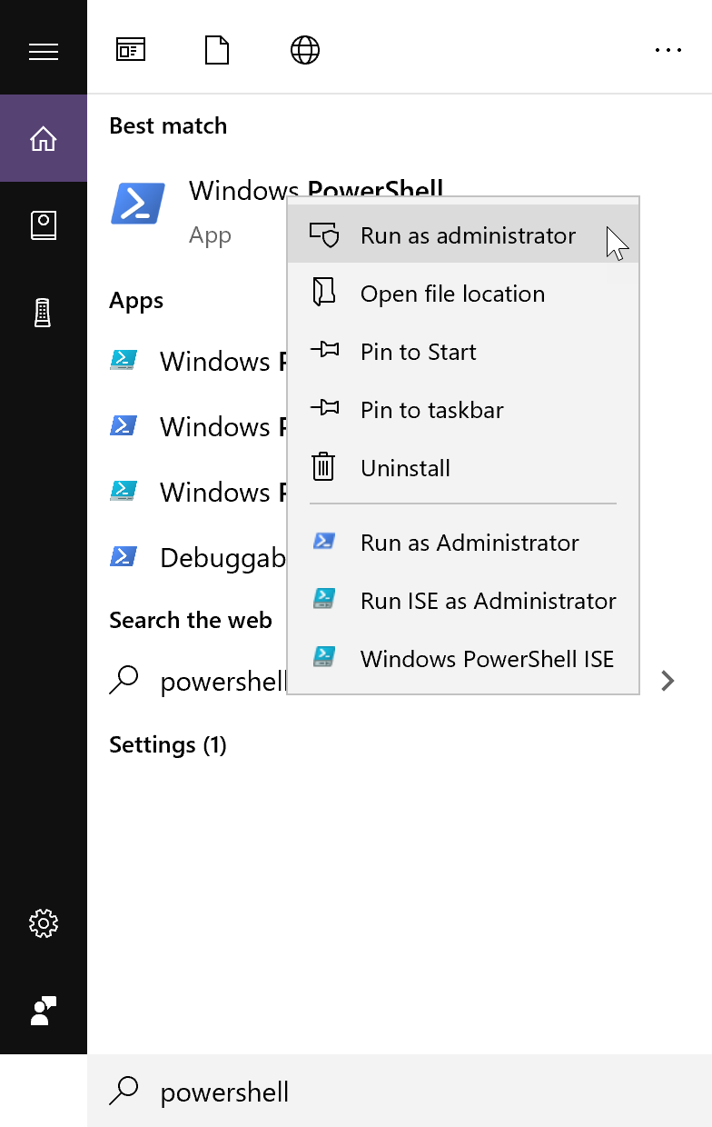
      4. On the command line run:

|  |
| --- |
| Enable-WindowsOptionalFeature -Online -FeatureName Microsoft-Windows-Subsystem-Linux |

* + 1. Restart your computer

1. Install your Linux Distribution of Choice  
   Most of you will get it from the windows store. If that doesn’t work for you, then follow the alternate directions provided and/or talk to a TA or instructor.
   1. Download and install from Microsoft Store
   2. Open the Microsoft Store
      1. Type “Microsoft Store” in the search bar.  
         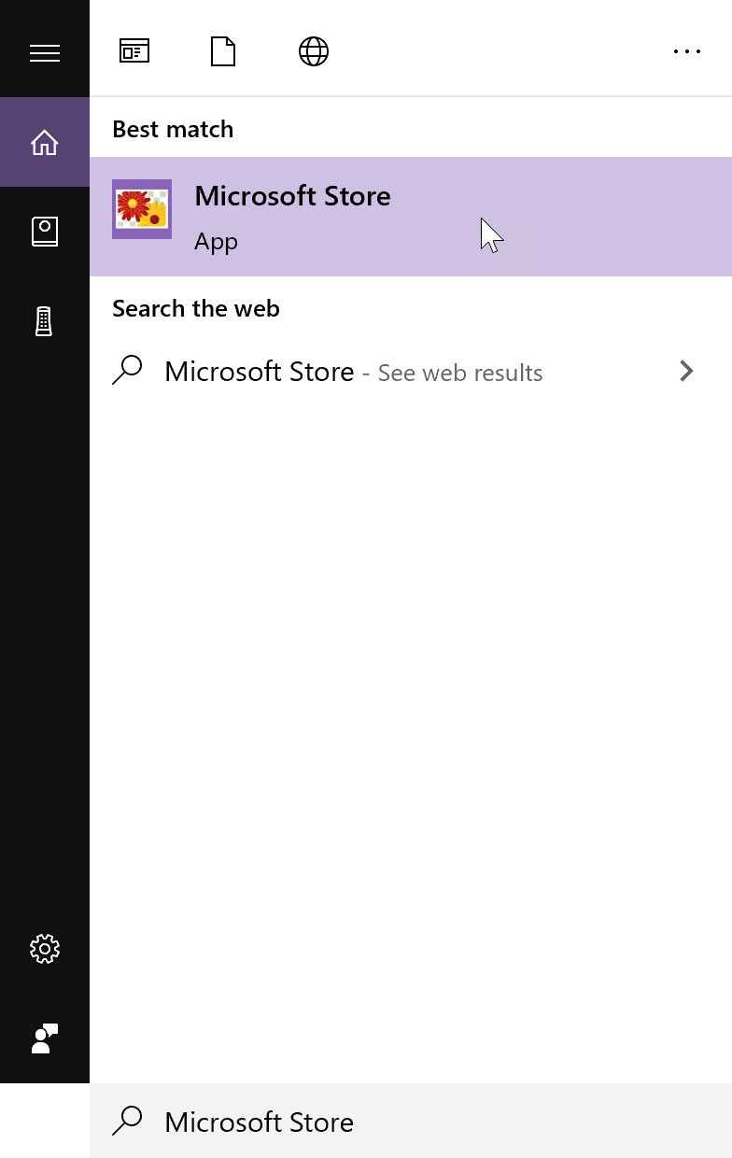
      2. In the store, search for “Ubuntu”  
         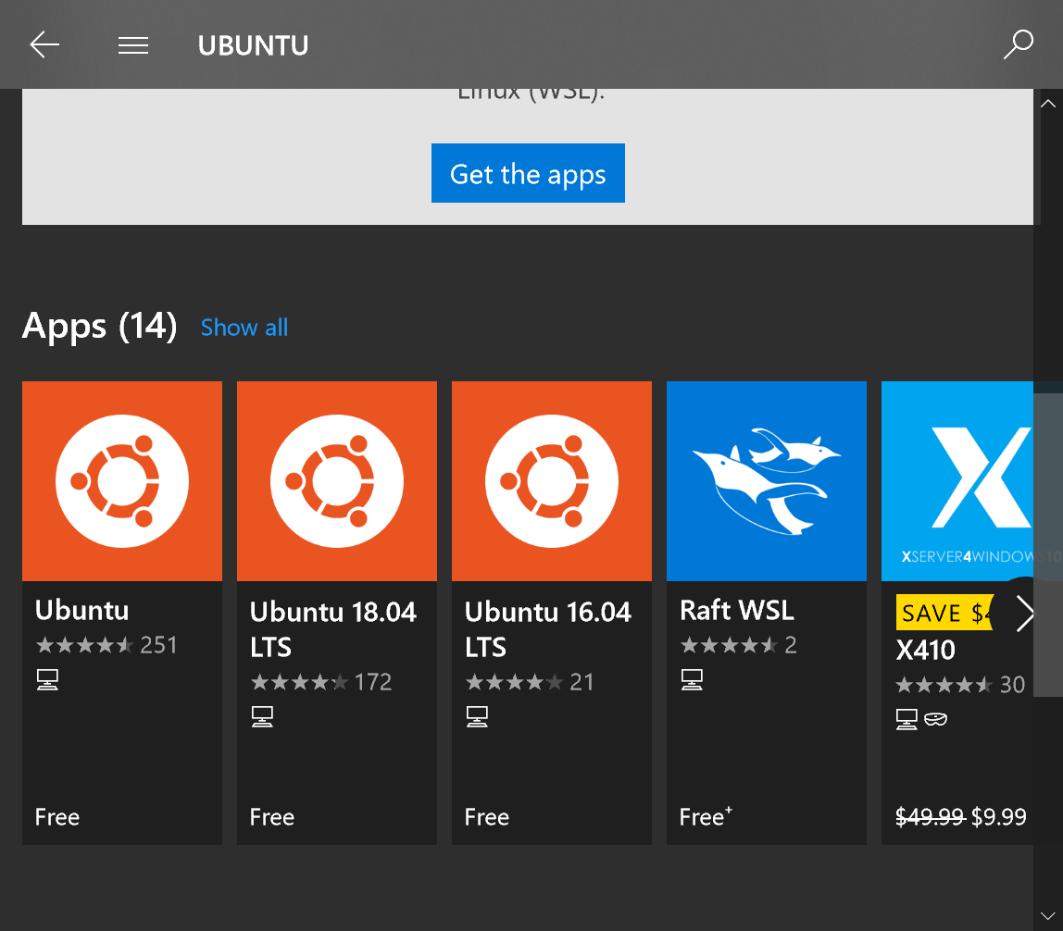
      3. Select “Ubuntu”
      4. From the distro page for the “Cononical Group Unlimited”, select “Get”  
         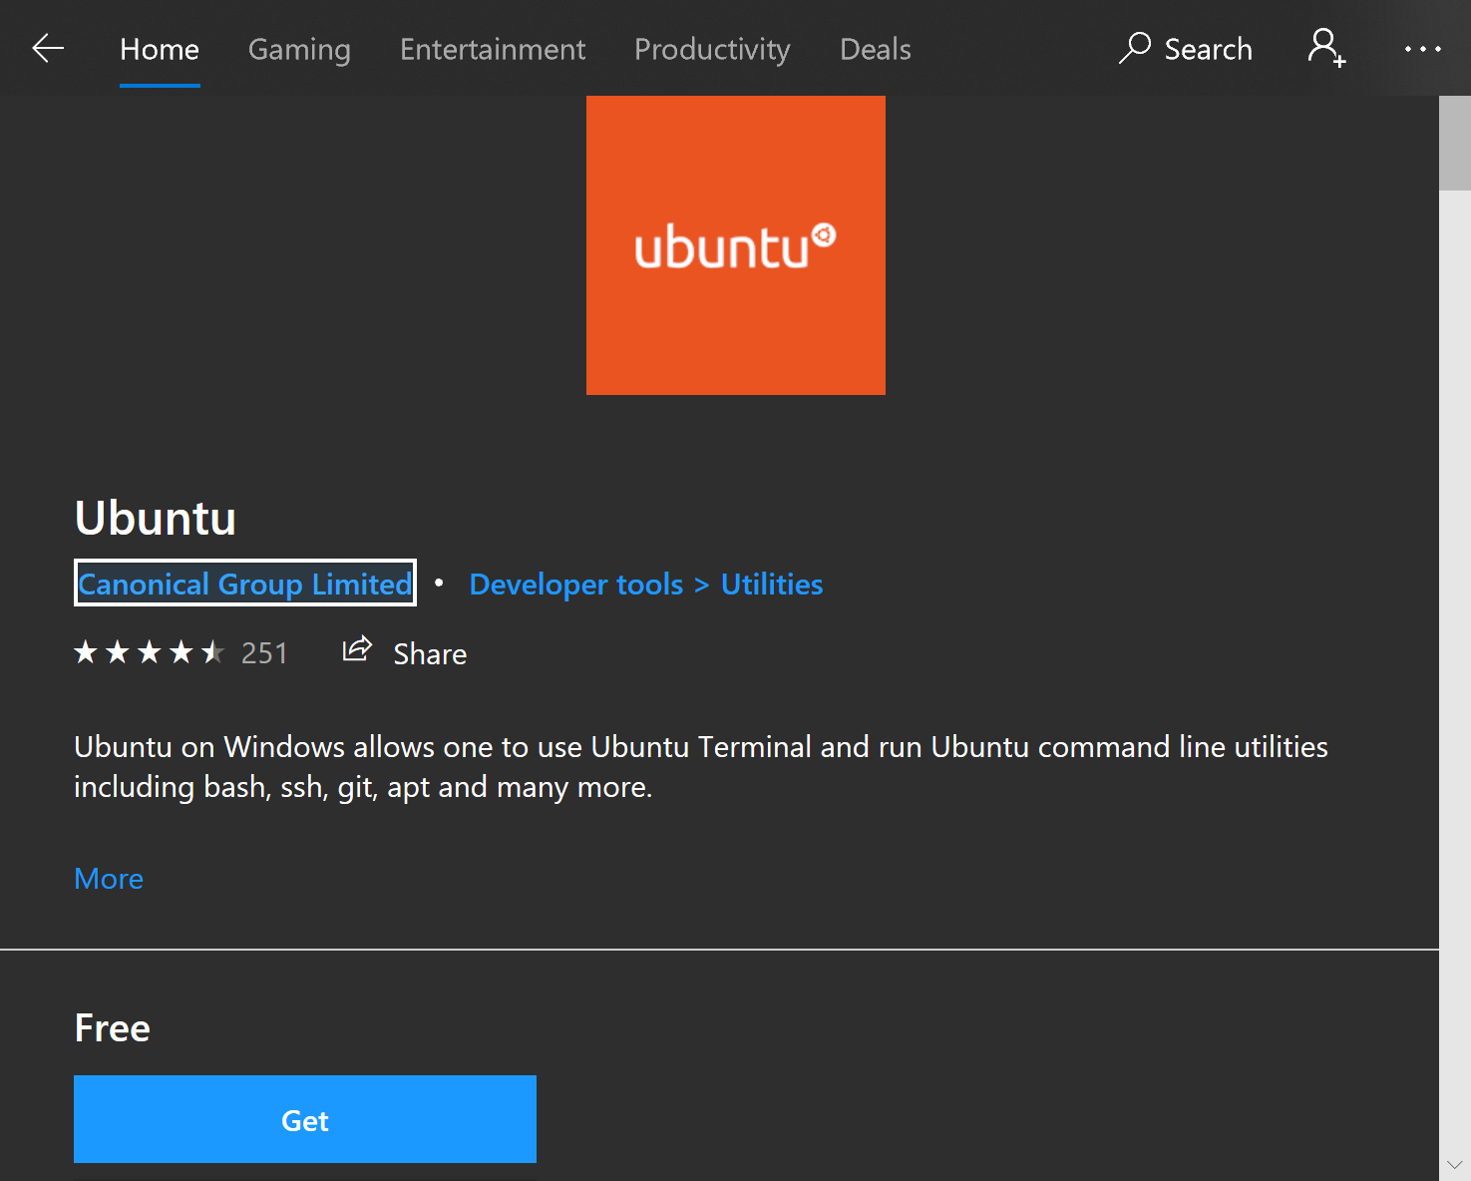  
         It should download the app after you select how you want to install it.
2. Initialize  
   After installing it, launch it.
   1. You can launch by selecting “Launch” from the Microsoft Store.
   2. You can type Ubuntu into the search bar and select Ubuntu from there.  
      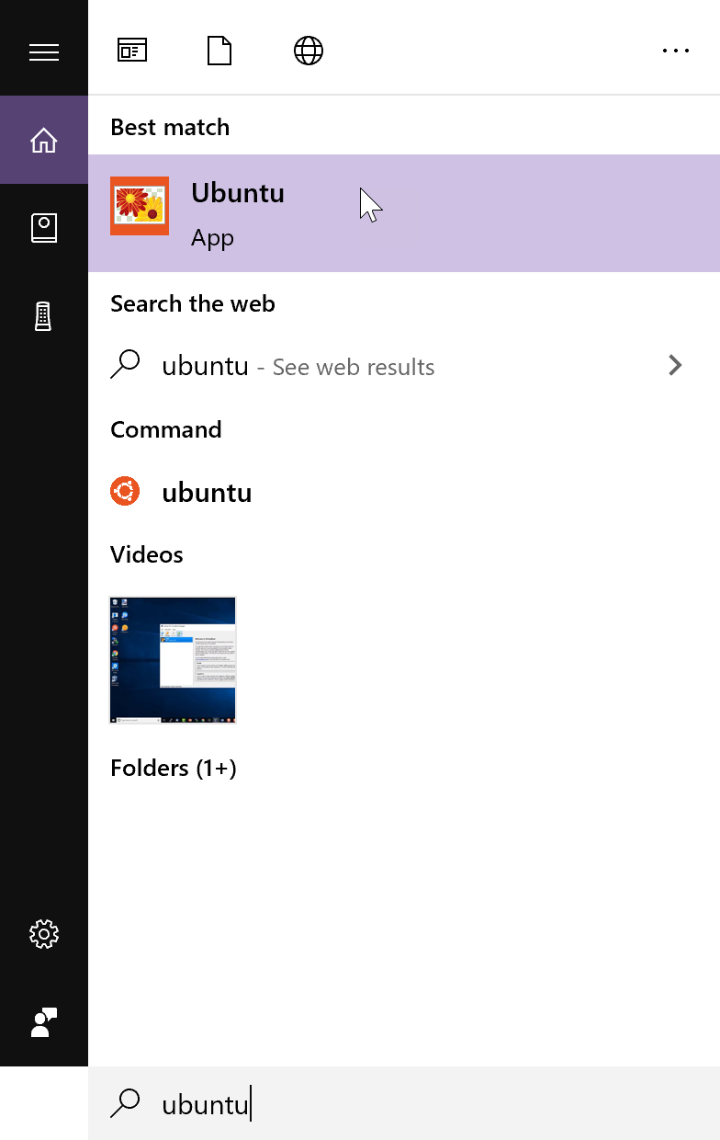
3. Setting up a new Linux user accountYou can use any username you want.  
   Make sure the password is something that you can remember since you’ll need it any time you use sudo (for example doing updates or installing the C++ compiler)  
   Note: You will not see characters being typed when you enter the password. Just know that it is taking whatever you type, so be careful.  
   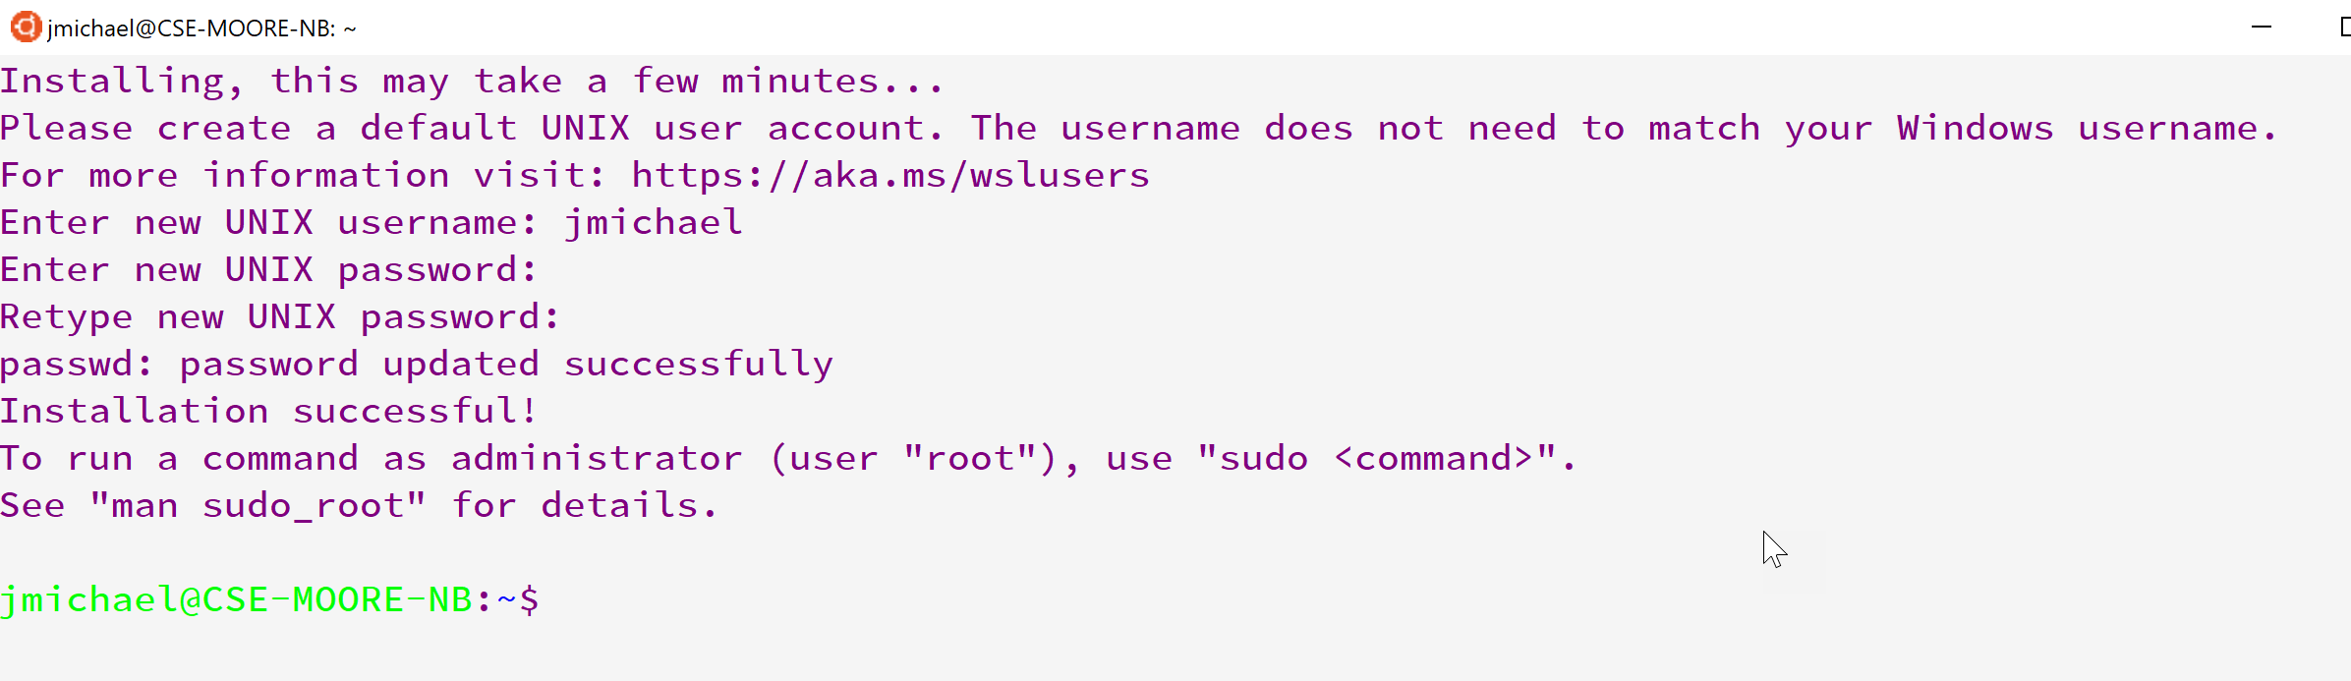
4. Update & upgrade your packages  
   In your Ubuntu shell type the following:

|  |
| --- |
| sudo apt update && sudo apt upgrade |

Provide password you used to set up.  
Note: If you have something on your clipboard, you can paste it in a command line by right clicking.  
Eventually it will ask if you want to continue. Type ‘Y’ or ‘y’.  
The updates can take some time.  
When it asks about restarting services chose whatever, but I chose ‘Yes’.

# Installing gcc, a C++ compiler

These instructions are based on:

<https://linuxize.com/post/how-to-install-gcc-compiler-on-ubuntu-18-04/>

1. In your Ubuntu command line execute

|  |
| --- |
| sudo apt update |

This should not be necessary, but better safe than sorry.

1. Then execute

|  |
| --- |
| sudo apt install build-essential |

Type ‘y’ when it asks if you want to continue.

1. (optional) Execute

|  |
| --- |
| sudo apt-get install manpages-dev |

1. Verify you installed gcc by executing

|  |
| --- |
| gcc --version |

The output should be similar to this:

|  |
| --- |
| gcc (Ubuntu 7.4.0-1ubuntu1~18.04.1) 7.4.0 Copyright (C) 2017 Free Software Foundation, Inc. This is free software; see the source for copying conditions. There is NO warranty; not even for MERCHANTABILITY or FITNESS FOR A PARTICULAR PURPOSE. |

# Files on your computer

You can access your c drive (and probably other drives) through your ubuntu shell. You can list the drives by executing:

|  |
| --- |
| df |

You’ll see /mnt/c. This leads to the C:/ drive on your computer. This is useful for the Unix Tutorial.

# Acknowledgment

Link to acknowledgement of completion is in eCampus.

# Text Editor Installation (optional)

You will want a text editor with syntax highlighting. Although it is not strictly necessary, it really makes reading code much easier.

You should avoid using the Notepad editor that is built into Windows.

## Text editor options for Windows:

However, these may not be as easy to use initially.

* [Notepad++](https://notepad-plus-plus.org/) (Preferred since it is easiest to use initially)
* [Sublime](https://www.sublimetext.com/)
* [Atom](https://atom.io/)
* [Visual Studio Code](https://code.visualstudio.com/)

## Command Line Text editor

For the brave souls out there, you can use vim or another command line editor that is out there. If you decide to go that route, you’re on your own. You can also install nano (during setup) for a gentler (but much more limited) text-editing experience.